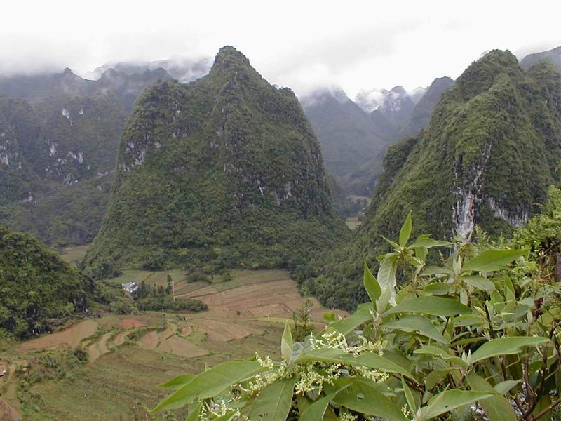

Figure 19: Cone karst peaks rise above the flat floored valley north of Lingyun County town.

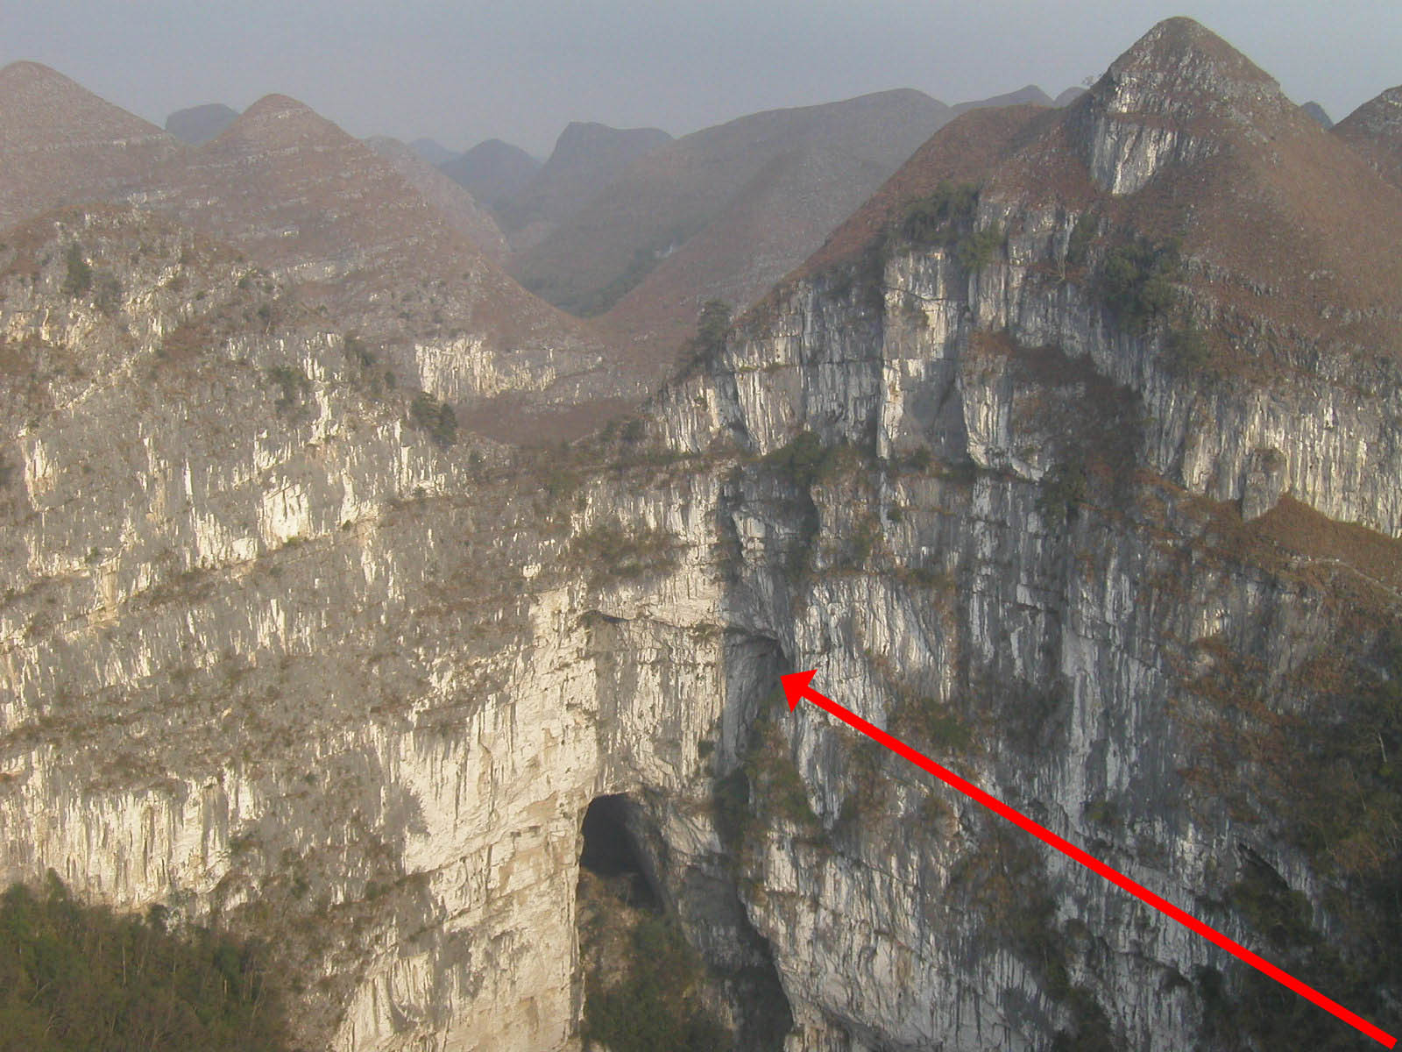

Figure 20: Looking into the 613m deep Dashiwei Tiankeng with arrow to Mafeng Dong.

A summary of the Guangxi 2000 exploration results

The enormous Dashiwei tiankeng was one of the many exciting karst features explored during our Guangxi 2000 expedition. Selected members of the Leye reconnaissance team explored (and surveyed) the massive Dashiwei tiankeng during the latter stages of our expedition in NW Guangxi. Located in a remote area of 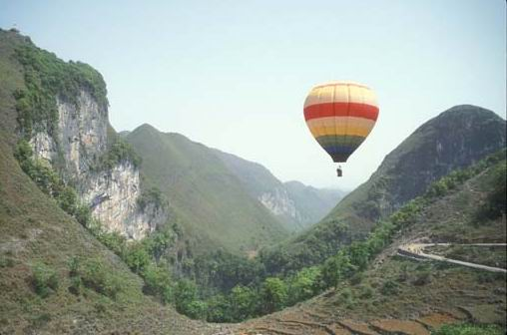

Figure 21: Hot air balloon over Dashiwei tiankeng in Leye County, NW Guangxi. (Photograph by James Alker, May 2001.)

cone karst about 20km from Leye County town (Figure 21), its surveyed dimensions are impressive: 613 metres deep, 600 metres wide (east-west) and 425m wide (north-south) with a 96,000m² area of virgin forest (dense primeval or “primary” tropical forest) with tall trees (Figure 22) on a steep sloping rubble floor that leads to a large cave entrance: Dashiwei Tiankeng Dong (Figure 24). 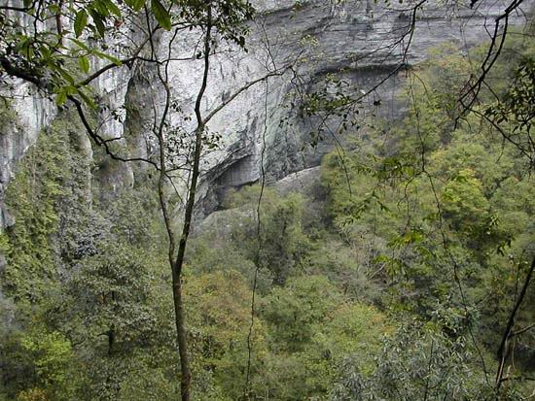

Figure 22: View of the dense canopy cover in primeval forest of Dashiwei tiankeng. (Photograph by Pete Hall, March 2002.)

There are two large upper level fossil caves (Mafeng Dong (Figures 20 and 23) and Zhong Dong) exposed in the tiankeng walls; Mafeng Dong is accessible to the public. The cave at the base of the Dashiwei tiankeng has some massive subterranean stream passages that include 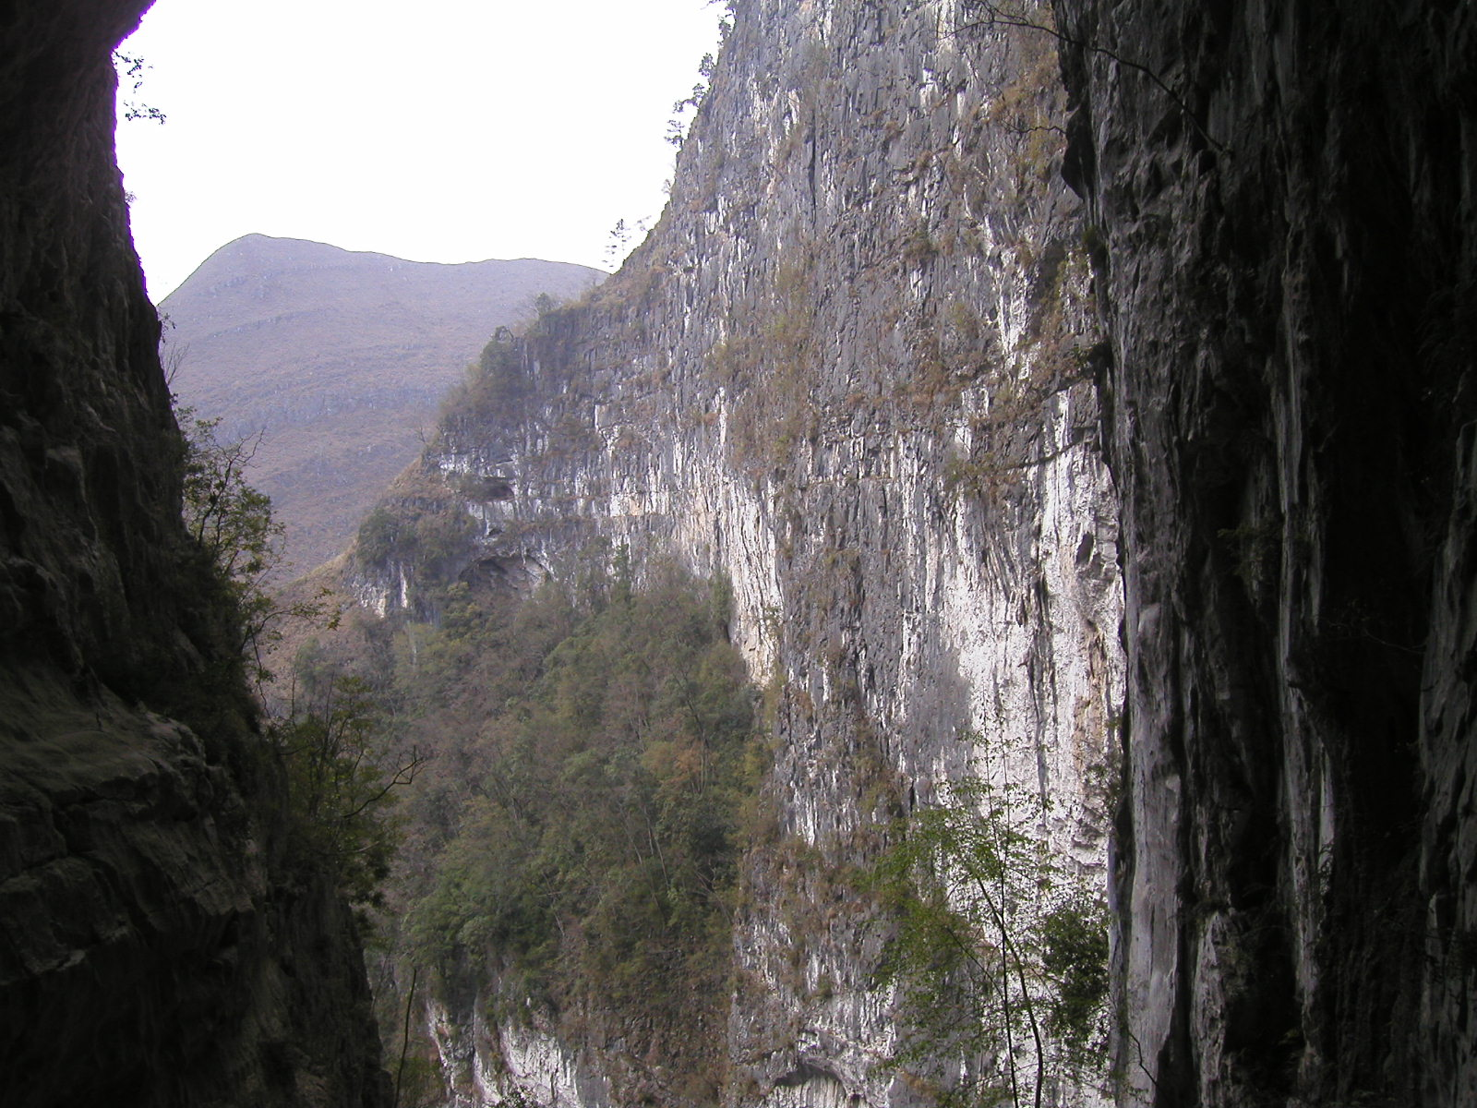

Figure 23: View to the vertical limestone walls of Dashiwei tiankeng from 25m high entrance of Mafeng Dong. (Arrowhead in Figure 20, shows position where the above photograph is taken looking out.).

the second and fourth largest underground chambers in the world. Dashiwei is now rated as the second largest (and deepest) doline (tiankeng) in the world, second only to the Xiao Zhai Tiankeng located near Xin Long in Fengjie County of southern Chongqing Province. (The Xiao Zhai Tiankeng and its cave has a total depth of 964 metres including the 600m height of 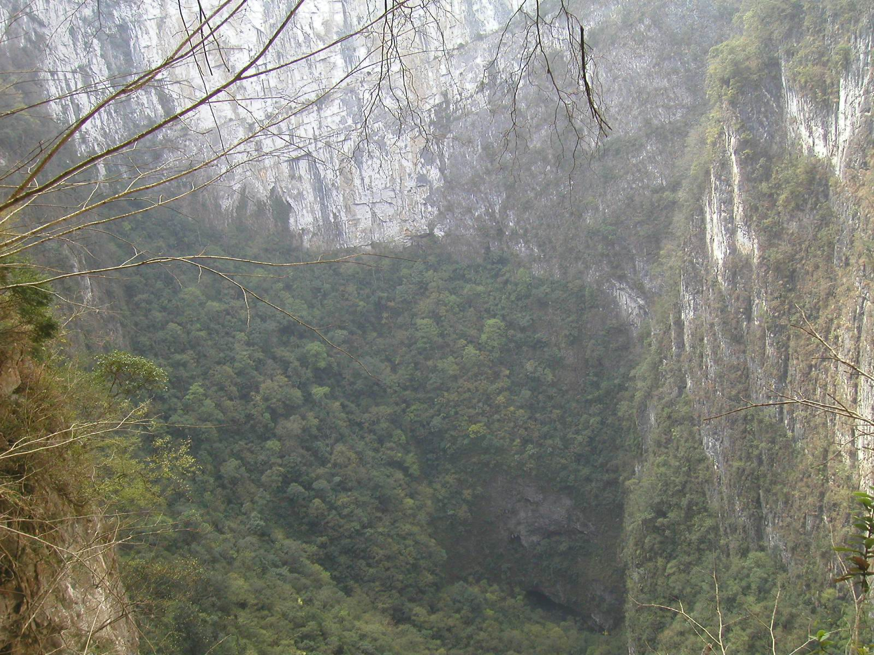

Figure 24: Telephoto view looking down to entrance of Dashiwei Tiankeng Dong, 613m below surface entrance of tiankeng.

daylight exposure with the vertical tiankeng walls above the slope leading down to the Xiao Zhai Tiankeng Dong cave entrance.) Along with all its associated cave passages and gigantic chambers, plus the magnificent primeval forest (with new undescribed tree species), Dashiwei features as one of the more significant and sensational karst discoveries found during the recent “Guangxi 2000” expedition (Campion, 2001). Two scenic roads are being constructed to provide access to both sides of the tiankeng and the site is scheduled to be ready for tourism on May 1st 2002. The subsequent tourist development will include walking tracks to lookout/ look-down viewing platforms above the tiankeng and another track into Mafeng Dong which will provide a caving experience in darkness, with tourists being able to walk through to the inside wall of the tiankeng and another lookdown view to the Dashiwei Tiankeng Dong cave entrance (Figure 24). The Dashiwei tiankeng is also being promoted for world heritage listing and management by international authorities as well as national and provincial Chinese interests.

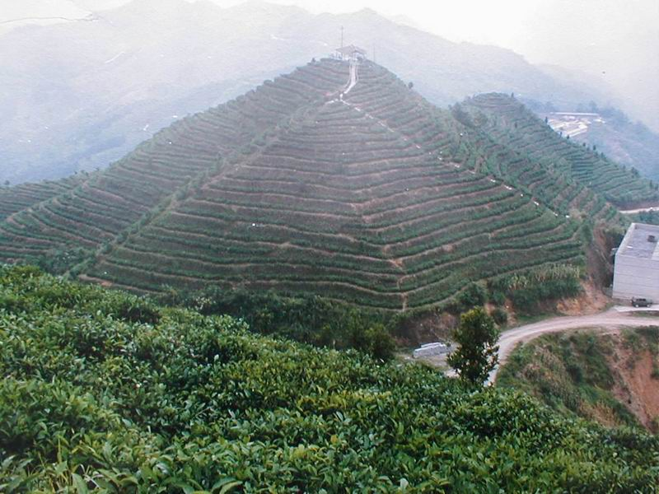

Figure 25: Tea plantations on the steep shale soil slopes near Lingyun. (Source: Tourism promotion display, Lingyun Hotel, NW Guangxi.)

Following is a summarised list of the major cave discoveries and karst features - in the Lingyun and Leye County regions of NW Guangxi - explored by members of our Guangxi 2000 expedition between 4-17 October 2000. The cave details and descriptions are excerpted from the published Guangxi 2000 expedition report in the Summer 2001 edition of the YRC Bulletin (Campion, 2001), with some added information provided by the writer. The published report details UTM grid reference locations (omitted here), entrance altitude, cave length, depth and the general nature of all the caves explored by members of the expedition in October 2000. Approximately 17 kilometres of subterranean passages were surveyed in a little over a fortnight of cave exploration. All the caves were surveyed to BCRA Grade 5 standard (i.e. bearings to within one degree and measurements within 10cm of the survey stations) using Suunto compasses and clinometers and Fibre glass tape. PDF versions of the cave surveys can be viewed and downloaded from: www.yrc.org.uk/china_caves.zip

